Lab: Arrays

In this lab, you will write code to retrieve the element in entity data model arrays.

Requirements

This lab requires that you use TrainingApp 8.0, Guidewire Studio 8.0, and Chrome as your web browser. To view, edit, and delete various contacts, log in to TrainingApp as Alice Applegate. The default URL for TrainingApp is <http://localhost:8880/ab/ContactManager.do>. The login/password for Alice Applegate is aapplegate/gw.

1. Working with Arrays

In this exercise, you will first create bank accounts for two contact.[1] Then, you will write Gosu code in Gosu Scratchpad to retrieve the objects in entity data model arrays. For each task, write Gosu code in Gosu Scratchpad that accomplishes the task.

Configuration

1. Log in to TrainingApp
2. Log in as Alice Applegate.
3. Create bank accounts for Eric Andy
4. Open the Eric Andy contact.

Write it down

On the Summary page, what is the Public ID for Eric Andy?

|  |
| --- |
|  |

1. Create two bank accounts:
   * Acme Credit Union -- Checking account
   * Acme Credit Union -- Savings account
2. Create bank accounts for William Andy
3. Open the William Andy contact.

Write it down

On the Summary page, what is the Public ID for William Andy?

|  |
| --- |
|  |

1. Create two bank accounts:
   * ACME Credit Union -- Checking account
   * National Bank -- Savings account

Tasks

1. Open Guidewire Studio for TrainingApp
2. From Studio, if your server is not already running, start the server using Debug 'Server'.
3. Review the Debug console for errors and verify that the application is running in the Debug console.
4. Open Gosu Scratchpad
5. Verify that the Run in Debug Process icon is available in Gosu Scratchpad.
6. Output the count the bank accounts per contact
7. Write Gosu code that outputs to the debug console the number of bank accounts for William Andy and Eric Andy.
8. Use the ta.QueryUtil.findPerson() method to retrieve each contact.
9. Output account details per contact
10. For William Andy and Eric Andy, print a numbered list starting from 1 where the list item consists of the bank, the account type, and the account number.
11. Use the ta.QueryUtil.findPerson() method to retrieve each contact.
12. Output account details only if contact has an account with the National Bank
13. If a there is at least one account in the array with the bank name "National Bank", print to the console: "This contact has a National Bank account".
14. Otherwise, print "This contact does not have an account with National Bank".
15. Use the ta.QueryUtil.findPerson() method to retrieve each contact.
16. Use an array method that requires a block as an argument.

Verification

1. Execute you Gosu Code in Gosu Scratchpad
2. Verify the console output.

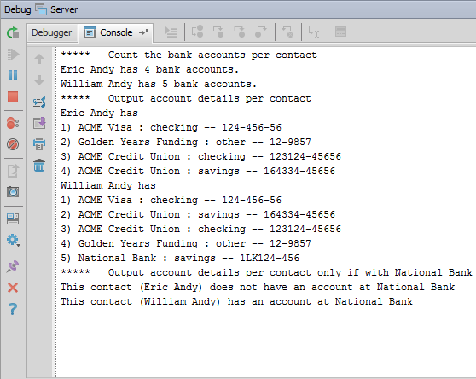

|  |  |
| --- | --- |
|  | Stop and ask your instructor to review your completed lab. |

1. In Project View, select the zTrainingOnly folder. Open CONF190_Arrays_Lab.txt. Open Gosu Scratchpad. Copy the contents of CONF190_Arrays_Lab.txt into Gosu Scratchpad. Run Gosu Scratchpad in the Debug Server process. Delete the contents of Gosu Scratchpad. Then, in TrainingApp, delete the National Bank account for the Eric Andy contact.